**Project Design Phase-II**

**Data Flow Diagram & User Stories**

|  |  |
| --- | --- |
| Date | 17 October 2022 |
| Team ID | PNT2022TMID30244 |
| Project Name | Project -Car Resale value Prediction |
| Maximum Marks | 4 Marks |

**Data Flow Diagrams:**

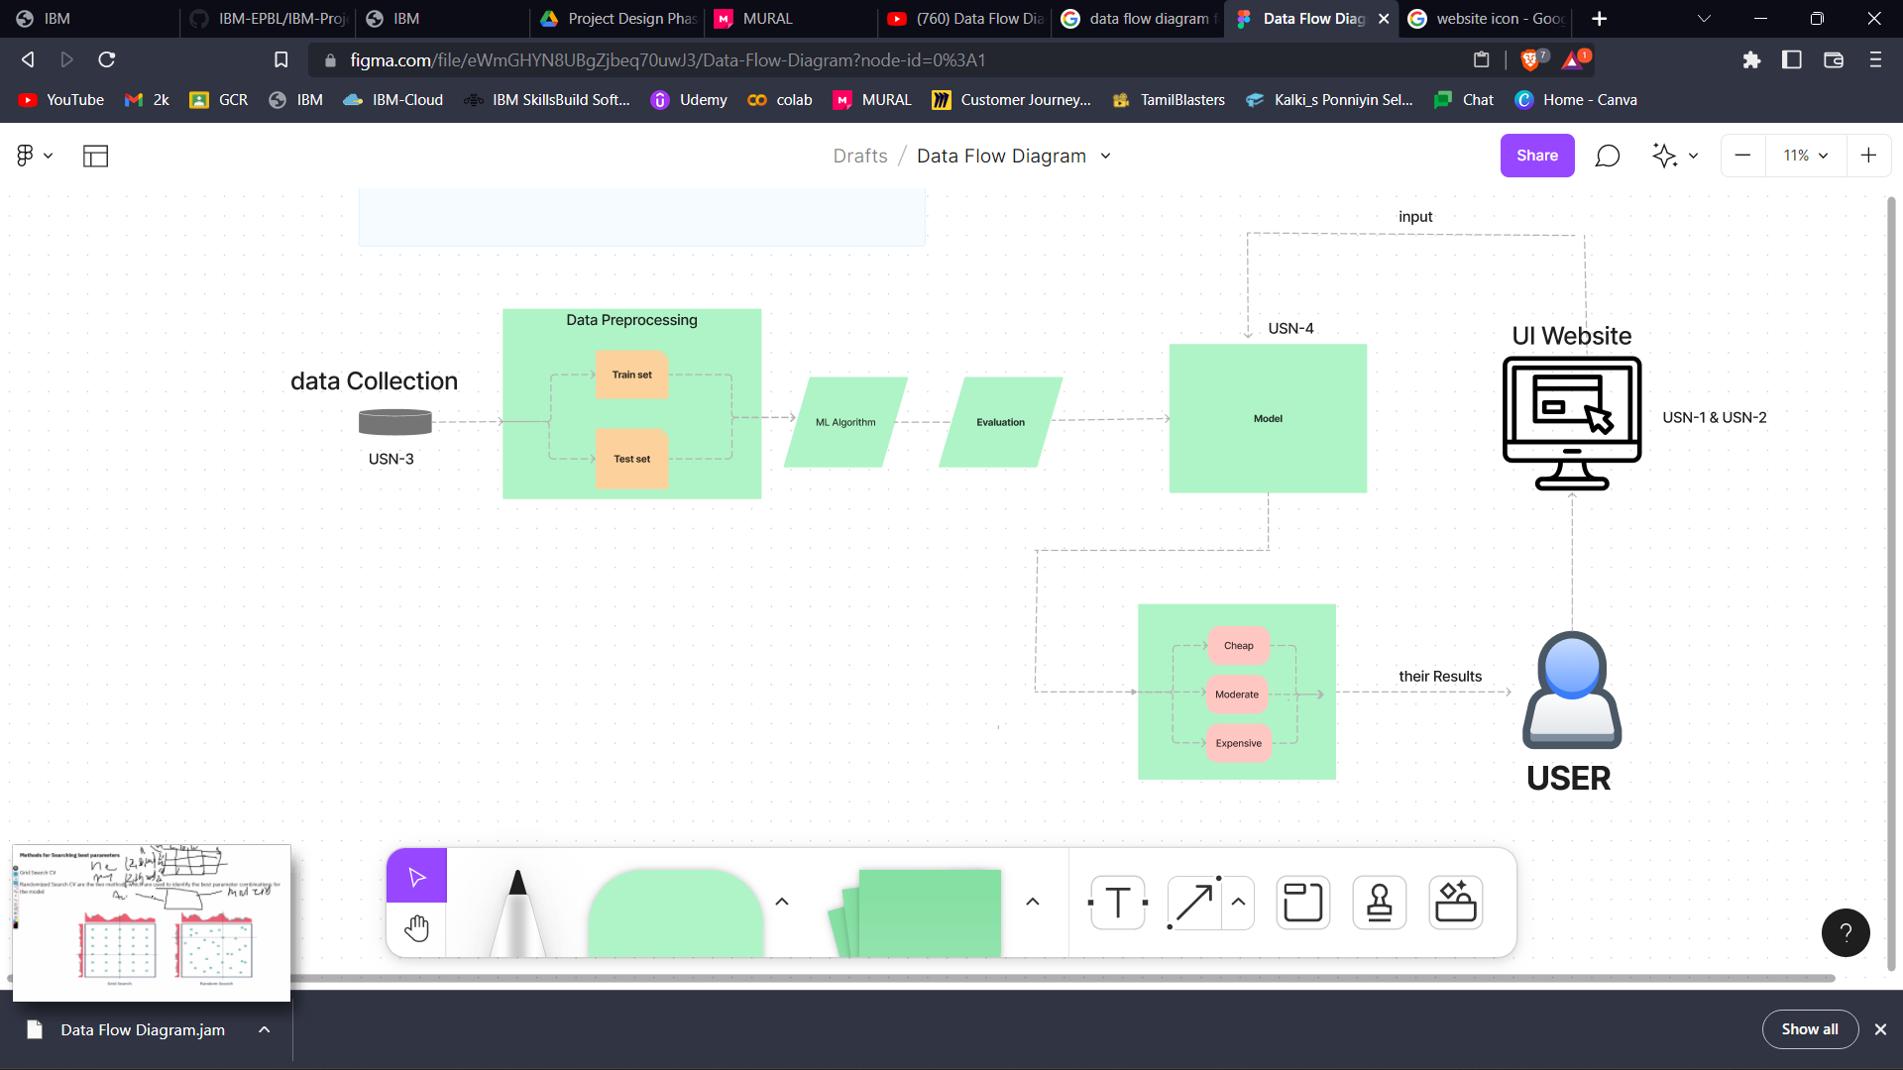

**User Stories**

Use the below template to list all the user stories for the product.

| **User Type** | **Functional Requirement (Epic)** | **User Story Number** | **User Story / Task** | **Acceptance criteria** | **Priority** | **Release** |
| --- | --- | --- | --- | --- | --- | --- |
| Customer (Mobile or computer user) | Registration or login | USN-1 | You can register our website by using our active Gmail account to access our data and information | you can access our website dashboard | High | Sprint-1 |
| Customer (Web or mobile user) | Dashboard | USN-2 | On this you have to give your requirements | We will check | High | Sprint-1 |
| Data analytics | Backend | USN-3 | We Collect the customers requirement and  Collect the related data | Process on going | medium | Sprint-1 |
| Data Analytics | backend | USN-4 | By using ML-Learning We process the data and give the exact result to the customer | You can see the result | High | Sprint-1 |